**HORN EXCERPTS FALL 2025-FSO and NAU**

**Listen to most of these at** [**https://www.hornsociety.org/hornexcerpts-org**](https://www.hornsociety.org/hornexcerpts-org)

**Beethoven — Symphony No. 3, Op. 55**

**Excerpt 3 – III. Trio: Allegro vivace**

Horn 1 in E-flat  
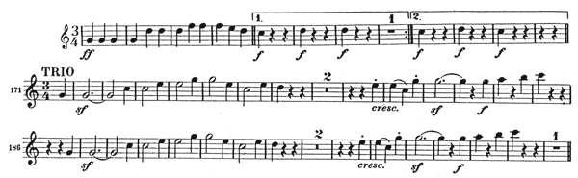

Horn 2 in E-flat  
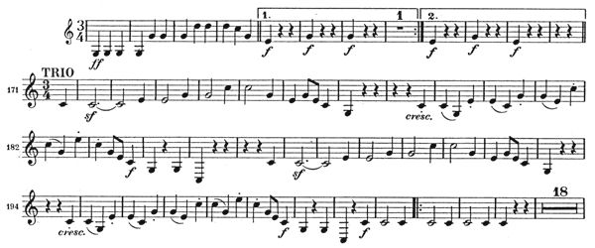

**Beethoven — Symphony No. 8, Op. 93 Excerpt 1 – III. Tempo di Minuetto**Horn 1 in F  
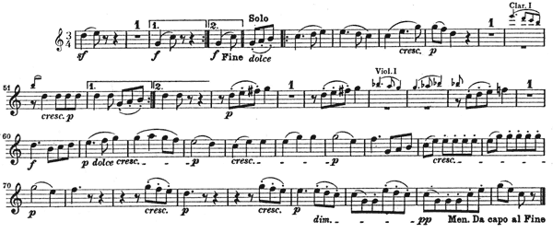

**Brahms — Symphony No. 4, Op. 98, Allegro non Troppo,** Horn 1 in E:  
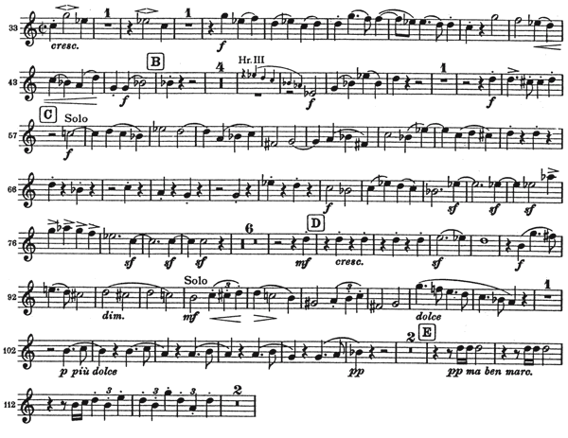

Excerpt 2 – II. Andante moderato

Horn 1 in E  
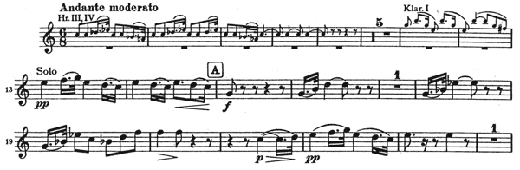

Horn 3 in C  
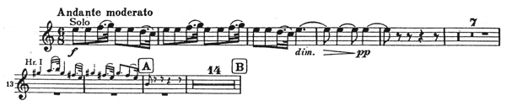

**Mahler Symphony No. 3, Excerpt 1**

**Horn 1 in F  
Movement I: Pickup to mm. 1-11  
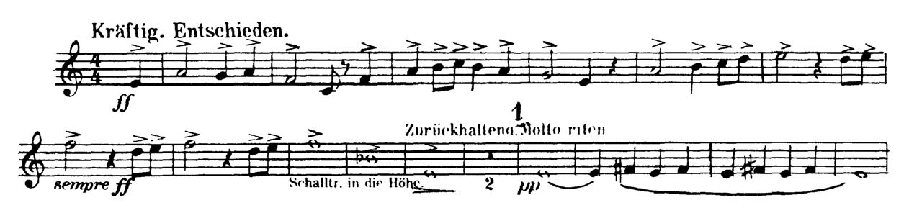**

**Horn 1 in F  
Movement I: Pickups to [29] to 2m before [33]  
**

**Horn 1 in F  
Movement I: [39] to [40]  
Horn 1 in F  
Mvt I: [51] to 3m before [54]  
Horn 1 in F  
Mvt I: Pickup to [55] to 4m. before [57]  
**

**Strauss — Till Eulenspiegel, op. 28**

**Excerpt 1 – Gemächlich**

Horn 1 in F  
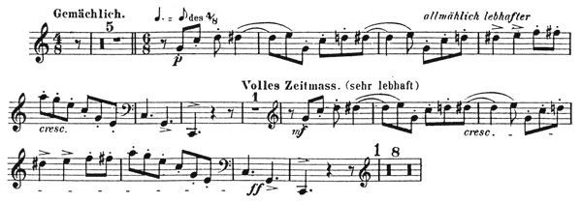

Horn 3 in F-\*\***only need to prepare the solo in D at Volles Zeitmas 13 bars before 29 to 29**  
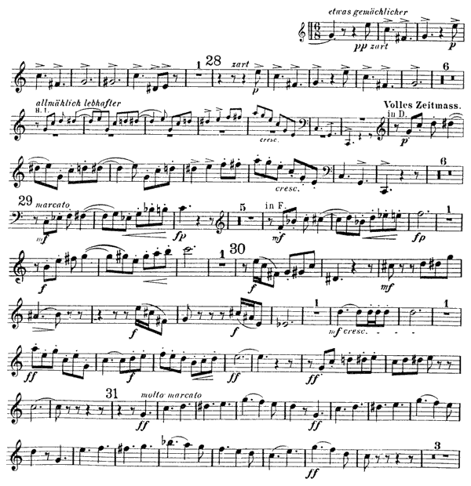

**Wagner- Lohengrin**

Horn 1 in G  
Prelude to Act III: Beginning to 1 measure after [3]  
